UrbanOS: The Digital Twin for the Net-Zero Metropolis



Group – 9

FTL Machine Learning Bootcamp

Team Members: Shin Thant Phyo

Htet Paing Linn

Htoo Thet Naung

Thet Hmue Khin

Naw May Thu Han

Shwe Yamin

UrbanOS: Data Preparation and Model Exploration Report

Data Preparation / Feature Engineering

1. Overview
The data preparation phase is critical for the UrbanOS project due to the diverse nature of our data sources. Our goal is to ingest, clean, and transform three distinct types of data:
- Time-series traffic data for our predictive LSTM model.
- Geospatial and IoT sensor data for our waste route optimization (VRP) solver.
- Real-time API data on grid carbon intensity for our Green AI Scheduler.
This phase ensures that the data is clean, normalized, and engineered into features that can be directly fed into our three distinct AI/optimization modules.

2. Data Collection
As specified in the project concept note, our data is sourced from public, real-world datasets:
- Traffic Data: Time-series traffic speed and volume data are collected from the NYC Open Data portal. This data provides historical, high-frequency sensor readings, which are essential for training a time-series forecasting model.
- Waste Data: IoT smart bin data is sourced from Smart Dublin and augmented with similar datasets from Kaggle. This data includes bin_id, location (latitude, longitude), timestamp, and fill_level (percentage).
- Carbon Intensity Data: Real-time grid carbon intensity (gCO2/kWh) is collected via API calls to ElectricityMap.org. This provides the "low-carbon" signal for our Green AI scheduler.
Initial preprocessing involves parsing these different formats (CSV, JSON API responses), standardizing timestamp formats (to UTC), and unifying data schemas.

3. Data Cleaning
Raw data from these sources contains anomalies that must be addressed:
- Missing Values:
  - Traffic: Sensors may temporarily go offline. We will use pandas.interpolate(method='time') to fill small gaps in the time-series data, providing a more realistic value than simple forward-filling.
  - Waste: Bins might fail to report. Missing fill_level data will be flagged, but not imputed, as a "no-data" state is different from an "empty" state.
- Outliers:
  - Traffic: Erroneous readings (e.g., speed = 0 for 24 hours, or speed > 200 km/h) will be identified using Z-scores and capped or removed.
  - Waste: fill_level values > 100% or < 0% will be clamped to the [0, 100] range.
- Duplicates: Duplicate timestamp and sensor_id entries will be dropped using pandas.drop_duplicates().

4. Exploratory Data Analysis (EDA)
EDA is performed to validate the patterns mentioned in our data review document and to inform feature engineering.
A. Traffic Data (for LSTM)
- Key Insight: Confirm cyclical and stochastic patterns.
- Visualizations:
  - Time-Series Decomposition: We plot the overall traffic speed, observing the trend, seasonal (daily/weekly), and residual (noise) components. This validates the predictable daily and weekly cycles.
2. Congestion Heatmap: A heatmap of average traffic speed by hour_of_day (y-axis) vs. day_of_week (x-axis). This clearly visualizes the morning (AM) and evening (PM) rush hours, which our model must learn.
3. Autocorrelation (ACF) Plot: An ACF plot on the traffic data shows a strong, slowly decaying correlation, confirming that past traffic states are highly predictive of future states and justifying the use of a stateful model like an LSTM.
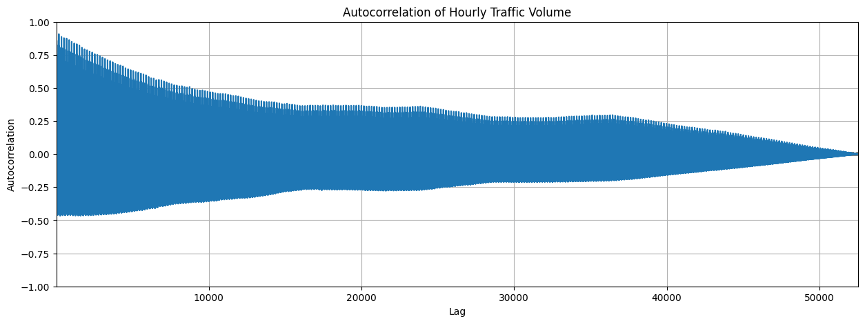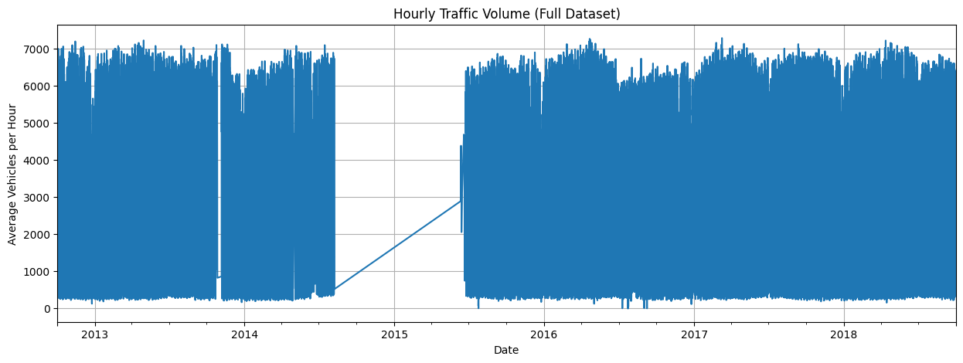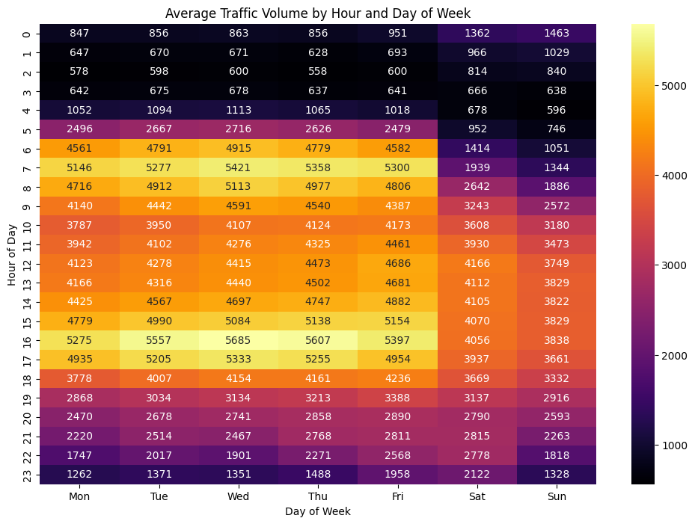
B. Waste Data (for OR-Tools)
- Key Insight: Confirm non-uniform fill rates to justify dynamic routing.
- Visualizations:
  - Geospatial Heatmap: Using Deck.gl, we plot all bins on a map of the city, color-coding them by their average fill_level. This confirms our hypothesis that fill rates are not uniform, with high-fill "hotspots" clustered in commercial districts.
2. Fill-Level Histogram: A histogram of current fill_level readings shows a right-skewed distribution, confirming that while most bins are not full, a significant number are at or near capacity, requiring collection.
C. Carbon Intensity Data (for Scheduler)
- Key Insight: Confirm high temporal variance to find "green" compute windows.
- Visualization:
  - Grid Intensity Time-Series: A line plot of gCO2/kWh over a 2-week period. This plot shows high volatility, with clear valleys (often at night or during high-renewable-generation periods) that represent opportunities for our Green AI Scheduler to run compute tasks.

5. Feature Engineering
Raw data is transformed into model-readable features.
- For Traffic (LSTM):
  - Temporal Features: We extract hour_of_day, day_of_week, and is_weekend from the timestamp. These are one-hot encoded.
  - Lag Features: We create features for previous time steps (e.g., speed(t-1), speed(t-5), speed(t-10)) as direct inputs for the model.
  - Rolling Averages: We calculate a 60-minute rolling average speed to smooth out short-term noise and capture the broader trend.
- For Waste (OR-Tools):
  - Distance Matrix: The critical "feature" for the VRP solver. We will use an API (like Google Maps or OSRM) to calculate the non-Euclidean (road network) travel time and distance between all bins (that are > 80% full) and the central depot.
  - Demand: The fill_level of each bin acts as its "demand."
- For Carbon (Scheduler):
  - is_low_carbon: A binary feature (True/False) derived from the gCO2/kWh value being below a predefined threshold (e.g., 100 gCO2/kWh).

6. Data Transformation
- Scaling (LSTM): All features for the LSTM model (speed, lag features, temporal features) will be scaled to a [0, 1] range using sklearn.preprocessing.MinMaxScaler. LSTMs are sensitive to the scale of input data, and this step is mandatory for good performance.
- Sequencing (LSTM): We convert the time-series data into supervised learning sequences. For example, we will use a function to take 60 previous time steps (60 minutes) as the input feature (X) to predict the next 1 time step (1 minute) as the label (y).

Part 2: Model Exploration

1. Model Selection
Our project uses a hybrid architecture, as defined in our concept note.
- Model 1: Traffic Prediction (LSTM Network)
  - Rationale: Standard statistical models (like ARIMA) struggle with complex, non-linear patterns and long-term dependencies. An LSTM (Long Short-Term Memory) is a type of Recurrent Neural Network (RNN) specifically designed to "remember" patterns over long periods (e.g., how this Monday's rush hour relates to last Monday's). Our EDA confirmed these complex temporal patterns.
  - Strengths: State-of-the-art for time-series forecasting, captures long-term dependencies, robust to noise.
  - Weaknesses: Computationally intensive to train, can be a "black box," prone to overfitting if not regularized.
- Model 2: Waste Optimization (Google OR-Tools)
  - Rationale: This is a classic Vehicle Routing Problem (VRP), a well-known logistics challenge. Instead of building a model, we use a dedicated, heuristic optimization solver. Google OR-Tools is a powerful, open-source library designed for exactly this.
  - Strengths: Highly efficient at solving complex routing problems, scalable, and provides concrete, actionable routes.
  - Weaknesses: It's a solver, not a predictive model. It finds a "good" solution (heuristic), which may not be the single "perfect" solution.
- Model 3: Green AI Scheduler (Rule-Based Controller)
  - Rationale: The task is simple: check if gCO2/kWh < threshold. A complex ML model is overkill. A simple, reliable rule-based controller (a Python script) is the most efficient and appropriate tool.
  - Strengths: Simple, transparent, zero computational overhead.
  - Weaknesses: Not predictive. It can't forecast future carbon intensity (though this could be a v2 feature).

2. Model Training
- Traffic (LSTM):
  - Hyperparameters: The model will be built using TensorFlow/Keras. Key hyperparameters to tune include:
    - LSTM Layers: 2 stacked layers (to learn hierarchical patterns).
    - Units: 50-100 units per layer.
    - Dropout: 0.2 (applied between layers to prevent overfitting).
    - Optimizer: Adam (an efficient default).
    - Loss Function: Mean Squared Error (MSE), as this is a regression problem.
  - Validation: We will use sklearn.model_selection.TimeSeriesSplit for cross-validation. This is crucial as random shuffling (KFold) would destroy the temporal order of the data and lead to unrealistic performance metrics.
- Waste (OR-Tools):
  - This model is not "trained." It is "configured" at runtime. The configuration includes:
    - The (dynamically generated) distance matrix.
    - The list of bins to visit (e.g., fill_level > 80%).
    - Vehicle capacities and the number of available vehicles.
    - The depot (start and end point).
- Scheduler (Controller):
  - This is not "trained." It is a script run on a timer that queries the ElectricityMap API and executes a simple if statement to decide whether to run delayed jobs.

3. Model Evaluation
- Traffic (LSTM):
  - Metrics: We will use Root Mean Squared Error (RMSE) and Mean Absolute Error (MAE). These are interpretable in the original units.
  - Visualizations:
    - Prediction vs. Actual Plot: The most important visualization. A line plot on the test set showing the Actual traffic speed vs. the Predicted speed. The closer these two lines are, the better the model.
2. Residual Plot: A scatter plot of the (Prediction - Actual) errors over time. We look for a random scatter around the zero-line, which indicates the model's errors are unbiased.
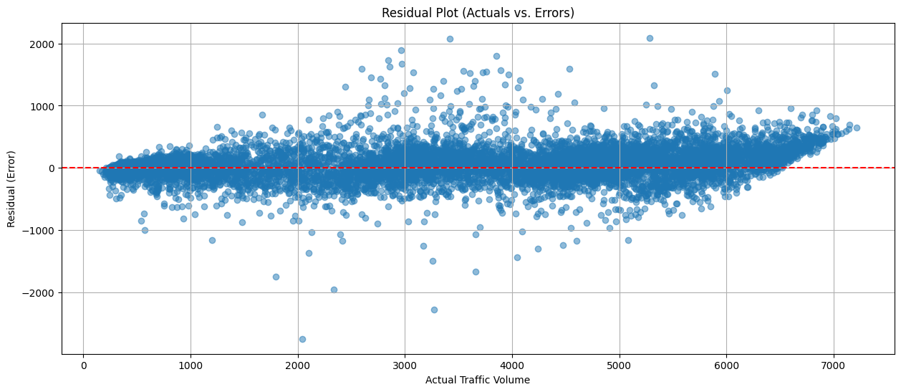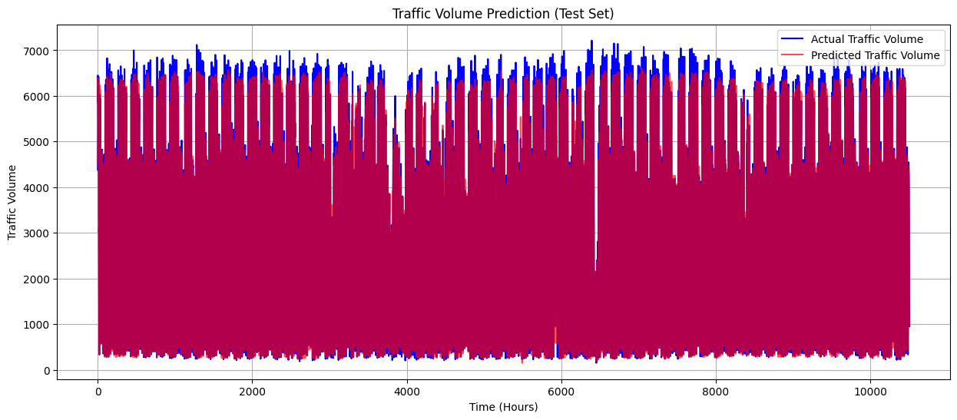
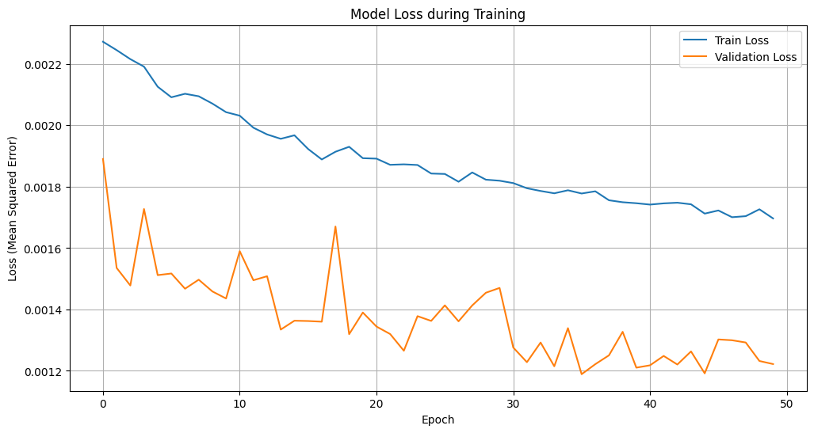
- Waste (OR-Tools):
  - Metrics: We evaluate the solution's efficiency: Total distance traveled, Total time, and Number of vehicles used. We will compare this to the current fixed-route schedule to quantify savings.
  - Visualization: A map (using Deck.gl) rendering the optimized routes as polylines, showing the efficient paths the trucks should take.

- Scheduler (Controller):
  - Metrics: gCO2 Saved. We calculate this by comparing the carbon cost of running a compute job (like LSTM retraining) instantly vs. the cost of running it at the time the scheduler chose.
  - Visualization: A simple bar chart comparing "Carbon Cost (Instant)" vs. "Carbon Cost (Scheduled)" for a typical weekly compute job.

4. Code Implementation
Here are key code snippets illustrating the process.
Snippet 1: Data Cleaning (Pandas)
print("\n--- [Cell 3/9] Cleaning Data and Performing EDA... ---")
df['date_time'] = pd.to_datetime(df['date_time'])
df = df.set_index('date_time')

# 'traffic_volume' as the target.
df_hourly = df['traffic_volume'].resample('h').mean()
df_hourly = df_hourly.interpolate(method='time') # Interpolate missing hours
print("\nCleaned and resampled hourly data:")
print(df_hourly.head())

Snippet 2: Feature Engineering (Pandas)
print("\n--- [Cell 4/9] Feature Engineering and Scaling... ---")
data = df_hourly.values.reshape(-1, 1)
scaler = MinMaxScaler(feature_range=(0, 1))
scaled_data = scaler.fit_transform(data)
# This function converts the time-series into X, y pairs
def create_sequences(data, sequence_length):
X, y = [], []
for i in range(len(data) - sequence_length):
X.append(data[i:(i + sequence_length), 0])
y.append(data[i + sequence_length, 0])
return np.array(X), np.array(y)
# Use 24 past hours to predict the next 1 hour
SEQ_LENGTH = 24
X, y = create_sequences(scaled_data, SEQ_LENGTH)
# Reshape X to be [samples, time_steps, features]
X = np.reshape(X, (X.shape[0], X.shape[1], 1))

Snippet 3: Data Transformation for LSTM (Sklearn/Numpy)
SEQ_LENGTH = 60
PRED_LENGTH = 5
X, y = create_sequences(scaled_data, SEQ_LENGTH, PRED_LENGTH)
# Split data (80% train, 20% test) - MUST be sequential
split = int(len(X) * 0.8)
X_train, X_test = X[:split], X[split:]
y_train, y_test = y[:split], y[split:]
print(f"X_train shape: {X_train.shape}") # (Samples, Timesteps, Features)
print(f"y_train shape: {y_train.shape}") # (Samples, Prediction_Timesteps)

Snippet 4: Model Definition (TensorFlow/Keras)
model = Sequential()
model.add(LSTM(
units=50,
return_sequences=True,
input_shape=(X_train.shape[1], 1)
))
model.add(Dropout(0.2))
model.add(LSTM(units=50, return_sequences=False))
model.add(Dropout(0.2))
model.add(Dense(units=1)) # Output layer
model.compile(optimizer='adam', loss='mean_squared_error')
model.summary()
# Train the model
history = model.fit(
X_train,
y_train,
epochs=50,
batch_size=32,
validation_data=(X_test, y_test),
verbose=1
)

